Instructions for preparation of abstracts for ICPEAC 2019
second line of title if needed but restrict the title to two lines

A Einstein^{1 *}, W E Pauli^{2 †} and E Schrödinger^{1,2}
Use only initial letters for first name, no full stops; use superscript number^{1,2...} for affiliation (10 pt)
and symbol*,† for corresponding author(s) (2 max) in footnote (10 pt)

¹Affiliation with laboratory and/or University name, city, zip code, country
²Affiliation with laboratory and/or University name, city, zip code, country

Synopsis Synopsis should be 16 cm wide with justified text. Use single-spaced lines with 10 pt Roman font. The synopsis should be explicit and concise with a maximum length of 600 characters including spaces. This synopsis is mandatory for publication of the abstract in IOP Journal of Physics: Conference Series (JPCS). If your abstract is selected for an oral presentation as a Special Report your synopsis will be printed in the conference program handbook. This synopsis must be copied in the abstract submission form.

This is a sample abstract for ISIAC 2019, with same format than the ICPEAC template.
1. Abstracts should be written in English. The abstract should fit on one A4 page without the page number. It should be submitted in PDF format together with the source files (text and figure) through the conference web site. Files larger than 1 Mb will be rejected.
2. It is your responsibility to check that the abstract is correctly formatted and readable. Incorrectly formatted abstracts will be rejected. Do not modify the pre-defined margins.
3. Use 11 pt Roman font for the text or a similar font such as Times New Roman throughout the abstract. Font sizes are listed in table 1.

Table 1. Font sizes to be used in the abstract.
 | Title | Authors-body | Affiliations-synopsis-  references
Size | 14 pt | 11 pt | 10 pt

4. The title should be typed in 14 pt boldface font and centered.
5. Leave an empty line (simple, 9 pt) after the title line(s), after the author(s) list and after the affiliation(s) list.
6. Leave an empty line of 18 pt after the sy-nopsis. Type the bodytext in two-column format with 0.75 cm column separation. The text should be single-spaced and the first line of each paragraph should be indented by 0.5 cm.
7. Only one figure file, which may display subfigures, is allowed. It will be shown in colour in the electronic version of the abstract. Give to the figure a separate caption (10 pt) and, like a table caption (10 pt), it should be concise. If you submit a colour figure it is your responsibility to ensure that it is easy to read and to be understood even in grayscale mode. When including the figure, pay close attention to not produce an oversized final PDF file.
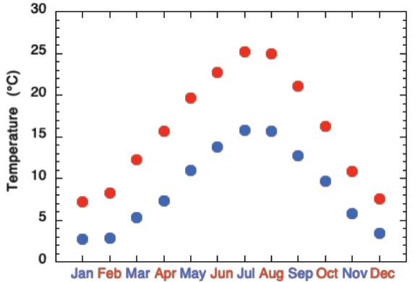
Figure 1. Average minimum (blue squares) and maximum (red circles) temperatures in Paris, France.
8. References in the text should be given by numbers in square brackets [1, 2] (“Vancouver system”). The list of references (10 pt) follows the last line of the text with one extra line inserted. Follow the style of JPCS (as Ref. [1] below).

References
[1] Ganesan A et al 2017 J. Phys. : Conf. Ser. 875 022021
[2] Reference 2 and so on

_________________________________________________________
* E-mail: corresponding.author1@domaine.fr
† E-mail: corresponding.author2@domaine.fr

